Lesson 17: Circumference, Area, and Degrees of a Circle
GETTING YOURSELF READY
Materials:  Mini whiteboards  Index Cards  Student Handout photocopies  Answers to Guided Practice completed and photocopied  Answers to last night’s Independent Practice completed and photocopied  Misconception to New Understanding Sheets |  |  | Your Preparation:  Put last night’s Independent Practice Answer Key and the Misconception to New Understanding Worksheet on a table for students to pick up on their way in to class. |  | Agenda with times:  Do Now and Purpose: 5 minutes  Key Vocabulary: 3 minutes  Building the Skill: 15 minutes  Structured Practice: 15 minutes  Guided Practice: 10 minutes  Closure: 2 minutes
GETTING YOUR STUDENTS READY
*Do Now:
Check homework and make a new row on the Misconception sheet for the trickiest problem you got wrong.
Objective: Today you will be able to understand the circumference, area and degrees of a circle. |  |  |  | Proving Behavior: By solving word problems involving the circumference, area, and degrees of a circle with 80% accuracy.
Purpose: Understanding circles will help you to solve complex geometric problems. You use measurements such as circumference, area, and degrees when you are making plans for construction or even planning out walking routes in your neighborhood.
Key Vocabulary: (from Glencoe.com)
Create vocabulary cards with these definitions and a picture to represent them and hang on the word wall. Use the cards to ask the students the given questions about the vocabulary and have them respond chorally or on their mini-whiteboards.
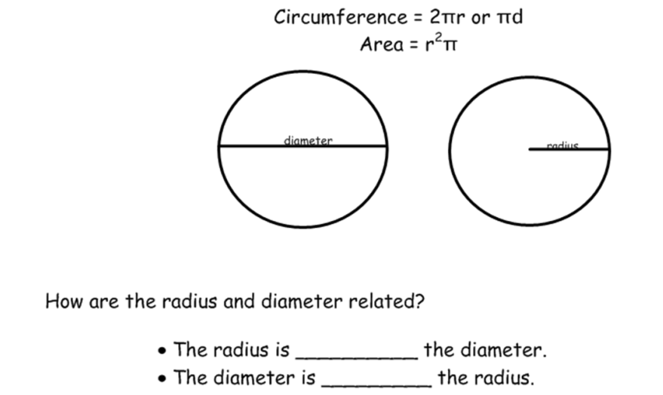
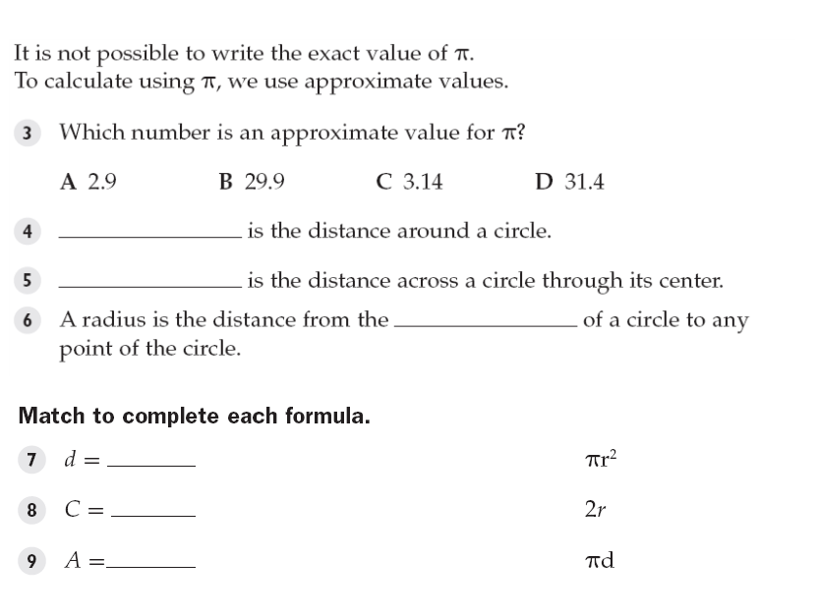
BUILDING THE SKILL
Finding the Circumference and Area of a Circle | Say/See: Dan Meyer’s Penny Circle Three Steps. I will also talk a bit about linear and quadratic equations.  Do: At each step, students will use the given handout to estimate how many pennies can fit into the big circle. At the end, they will discuss the findings and whether it makes sense or not.  Say/See: Say and show each step of the VIP: Circumference.  Do: Have the students split their whiteboards into two columns. In one column, have them draw a circle and label the radius 4 cm. In the other column, have them draw a circle and label the diameter 8 cm. Have them show you their boards so you can check their understanding of the vocabulary. After each step you say and show of how to find the circumference, have the students complete that step for the number using their mini whiteboards.  Say/See: Say and show each step of the VIP: Area. Notice how the formula is written r^{2 *} pi, instead of pi*r². The reason for this is to cut down on the students mistakes of multiplying the pi times the radius and then squaring. This way, they automatically square the radius first and then multiply times pi. Also, they will usually write their answers keeping pi as the symbol, so all they have to do is radius squared and then write the pi symbol after.  Do: Have the students continue with the circles they already have drawn on their whiteboards. After each step you say and show of how to find the area, have the students complete that step for the number using their mini whiteboards.  Say/See: Think aloud how you might create an example to test the question, “What would happen to the area of a circle if we doubled the radius?”  Do: Have students work with a partner and create an example to test the question and write out their thinking. Cold call for students to explain what they concluded and how they concluded it.
Degrees of a Circle | Say/See: Say and show each step of the VIP: Filling Out the Decimal, Percent, Degrees Chart. Note that the VIP assumes prior knowledge of how to convert from a fraction to a decimal and a decimal to a percent and solve a proportion. It is possible that you may have to think aloud the reminder of how to complete these operations.  Do: After each step you say and show, have the students fill in that step for problem 1 (MARK) and then complete that step for CUONZO—showing you each step on their whiteboards before you move on to the next step. After you have finished the VIP steps, have the students work with a partner and complete the rest of the table as a whiteboard drill. Have them double check that all the totals work—the decimals should add up to 1 whole, the percents to 100% and the degrees to 360. Then have them work alone and complete all of number 2 as a whiteboard drill.  Say/See: Think aloud how to complete number 3 using the chart information in number 1. Show each step.  Do: After each step you complete, have the students complete that step to fill in the graph for number 4 based on their table in number 2. Have them show you their work, one step at a time.
PRACTICING THE SKILL
*Structured Practice (3-4 additional examples led by teacher with gradually quickening pace, helping students approach automaticity by manipulating, time, materials, group size)
Time: 5 minutes  Materials: Word Problems  Group Size: Pairs  Materials: Mini Whiteboards |  | There are two sets of problems for the Structured/Guided Practice. Have the students complete the first problem of each section, one at a time, with a partner and hold up their whiteboards for you to see their answer. Because they are word problems, require the students to use their strategy of visualizing. They should draw some picture to represent the problem before solving or interact/label a given picture. If the students are proficient, they may go on and use the remaining problems as their Guided Practice. If they need more help, you may do a whole class think aloud or give them another problem in the section to complete with a partner before releasing them to Guided Practice.
*Guided Practice (the proving behavior of the objective monitored by teacher)
Assignment: Guided Practice Handout. Have the students complete the remainder of the word problems. Make sure they show their visualization for each problem. |  |  |  |  |  | Criteria for Mastery: 80% of the remaining problems.
Explain Homework: Independent Practice Handout
*Closure: Draw me the best looking circle possible on your whiteboard and its approximate circumference and area.

